**Motto**: GHMS Students are reaching for the top of the Hill

**Mission**: GHMS will provide skills that are essential for students to become positive, productive, and resourceful citizens of society.

**Vision**: Creating a model middle school that inspires students to impact their community.

**GHMS School Council**

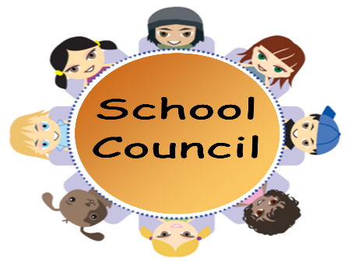

**December 8, 2016 @ 10:00 am**

**Parent Resource Room # 41 6th Grade Hall**

**Minutes**

**Meeting of GHMS School Council was held in the Parent Resource Room, 6th Grade Hall on Thursday , December 8, 2016 at 10:32 a.m. Welcome by Miss Clark, Parent Facilitator. President Mr. Eddie Furse (ill). Mr. Remell Wright, GHMS Counselor presided over the meeting. The minutes of the last meeting were read by Mr. R. Wright with no corrections. Mr. Wright suggested school council officer, available (in progress). Mr. Wright suggested that all members watch the member training video slides on RCSS Website. Mrs. Pinckney , a grandparent suggested a Parent Café. The café would give parents and administrators a chance to sit down a talk about issues of importance to them. Mr. Wright suggested that council meet with Ms. Brown on “How to build a Council”.**

**Mr. Wright and Mrs. Caldwell talked a doing a Parent University. The Parent University would meet once a month in the cafeteria and auditorium. The Parent University would consist of meetings like parenting classes, Attendance etc. They wanted the first Parent University to be held January 24, 2017 at 5:30 pm.**

**The Parent University is asking parents to become full partners in their child(rens) education. The Parent University will be for the 6th grades (the first year of middle school). Example activities of the Parent University, Infinite Campus, Student Services, Attendance Parenting Classes, etc.**

**Meeting Adjourned.**

**Elizabeth Hoilins, Secretary**